MD.065 - Module Functional Requirements
Qualcomm, Inc.
Siemens label (BAX Dev.)
(Kintana 52870)
Author: David Park
Creation Date: April 13, 2005
Last Updated: June 12, 2005
Control Number:
Version: 1.1

Approvals:
John Carley | May 13, 2005_________________________________________
David Park | May 13, 2005_________________________________________
Marie Rousseau | May 13, 2005_________________________________________
To add additional approval lines, Press [Tab] from the last cell in the table above.
You can delete any elements of this cover page that you do not need for your document. For example, Copy Number is only required if this is a controlled document and you need to track each copy that you distribute.

Document Control

Change Record

Date | Author | Version | Change Reference
13-APR-05 | David Park | 1.0 | Draft version
14-APR-05 | Ken Hatfield | 1.1 | IT Review / Updata

Reviewers

Name | Position
John Carley | Data Analyst, Associate
Marie Rousseau | System Analyst, Senior
David Park | Business Process Analyst

Distribution

Copy No. | Name | Location
 | Library Master | Project Library

The copy numbers referenced above should be written into the Copy Number space on the cover of each distributed copy. If the document is not controlled, you can delete this table and the Copy Number label from the cover page.

Contents
Document Control ii
Functional Overview 1
Basic Business Needs 1
General Rules and Error Handling 1
Definitions for Siemens 2S Inner Box Label 1
Business Rules 2
Assumptions 2
Forms updates 2
Label updates 2
Open Issues 3
Closed Issues 3

To update the table of contents, put the cursor anywhere in the table and press [F9]. To change the number of levels displayed, select the menu option Insert->Index and Tables, make sure the Table of Contents tab is active, and change the Number of Levels to a new value.

Functional Overview
The contract with Siemens requires specific labeling which includes the Siemens customer part number and unique bar coding. The Siemens requirements are different than 2S Inner Box label requirements currently in place for other Qualcomm customers.
The Siemens label requirement includes placing a 2S inner box label on the inner box (pizza box), the ESD bag, and the reel inside the static bag. Further discussion with Siemens allows Qualcomm (or their agent) to either; 1) place a label on the inner box, one on the ESD bag, and one loose inside the inner box, or 2) print on‘re-useable’ label stock and affix a label on the inner box and one on the ESD bag. In either plan the customer, Siemens, will place the label on the reel when the static bag is opened.
The Siemens inner box label consists of human readable characters as well as barcodes in the code39 format (that used on our current label templates).
Due to the logistics involved in supporting the Siemens account these Siemens custom 2S Inner Box labels must be supported by Oracle (DC San Diego), Exceed (DC Singapore), and the 3PL running the European distribution center (DC Netherlands).
For Exceed all data required for the 2S label will be provided in the SO message.

Basic Business Needs
This enhancement request supports the business units need to create specific labels for shipping product to Siemens. By providing this enhancement customer specific label required to meet the contractual agreement with Siemens will be met.
The customer has asked for an example of their 2S Inner Box label that they can validate the format and barcode data. To satisfy this need creation of a prototype label is requested as soon as possible.

General Rules and Error Handling
BAX has in place a method to print 2S customer specific labels for QCTAP customers. This enhancement requires a different label format be used for Siemens shipments, and only for shipments destined for Siemens (either direct ship to Siemens or via the ESL). The existing 2S label format must continue to be used for other QCTAP customers.

Definitions for Siemens 2S Inner Box Label

Cust Prod ID (Customer Product Identification)
This is the part number supplied by Qualcomm’s customer that equates to the Qualcomm part being shipped. This number will be used by Customer Service when creating the sales order lines as the ‘part’ and will appear as the ‘customer part number’ in the Shipment Order Detail message (940D).

Siemens Part Number
Same as the Cust Prod ID above, but specific to Siemens part numbering. Again, this will be pulled from the Shipment Order Detail message (940D), customer part number field.

Quantity
This represents the quantity of individual chips, on the reel inside the inner box. This too will be pulled form the Shipment Order Detail message (940D), but must reflect the quantity included in the box on which the label is placed. For example; if 5,000 of lot A are being shipped and lot A is 5 boxes each of 1,000. The the label on each box must show quantity of 1,000.

Business Rules
This enhancement request assumes standard shipping business process when supporting a customer shipment where customer specific labels have been called out by Customer Service and agreed upon by Operations.
Define specific business rules that the customization must provide. These rules can form the basis of a user acceptance test.

Assumptions
This design assumes that the following statements are true:
- The user (BAX) has the responsibility to print the labels and to adhere the labels to the inner box and ESD bag.
Add to or modify this list as appropriate. Provide additional details where necessary to facilitate the creation of the installation routines.
Indicate the specific menu options added to access new forms.

Forms updates
BAX to determine forms modifications required for the Exceed system.

Label updates

Siemens Label:
The existing Inner Box label will need to be modified to support 25 characters of customer product ID description in the human readable and the barcode areas. The label stock will be 2” by 4”. Standard business process shall define the use of a reusable label stock that the customer, Siemens, can remove from the ESD bag when opened and affix it to the reel within.

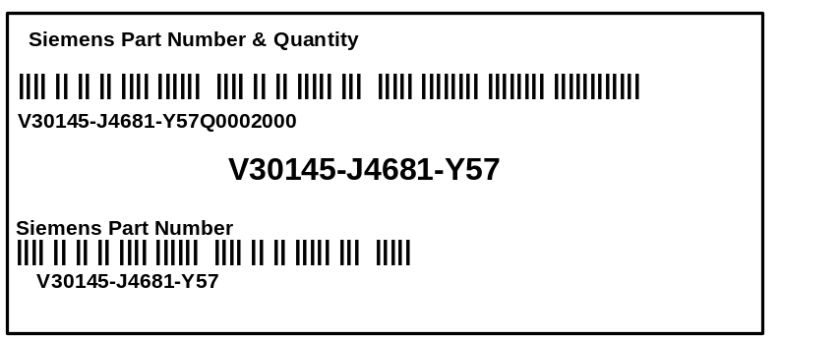
The following data elements continue to be printed on the label:
- Item Name (field label “Siemens Part Number & Quantity”)
- Code39 barcode representing ‘CUST PROD ID’ and Reel quantity (separated by the letter ‘Q’ as the data identifier)
- Human readable ‘CUST PROD ID’ and (separated by the letter Q) Quantity in one line.
- Middle of the label to display the customer’s material description (V30145….) in human readable format (larger font that the rest). This is the Cust PROD ID from above.
- Item Name (field label “Siemens Part Number”)
- Code39 barcode representing ‘CUST PROD ID’
- Human readable ‘CUST PROD ID’
Add open issues that you identify while writing or reviewing this document to the open issues section. As you resolve issues, move them to the Closed Issues section and keep the issue number the same. Include an explanation of the resolution.
To prevent Word version 7.0 from automatically renumbering your issues, turn off the automatic formatting of numbered lists in Tools-> Options. Select the AutoFormat tab, activate the AutoFormat As You Type radio button, and uncheck the option labeled Automatic Numbered Lists.

Open Issues
None

Closed Issues
- Not sure where the customer material description would be retrieved from. We are investigating this (David P).
- Customer description will be pulled from the cross reference table used today. If description does not exist none will display.
- Lot Date Code is lot specific and exists on the vendor supplied 2S label. Customer specific Inner Box labels are item specific and lot date code is too granular to include.
- This issue resolved when Siemens removed the requirement to include the date code on the customer specific label.
- Lot Country Code for Assembly Site is lot specific and exists on the vendor supplied 2S label. Customer specific Inner Box labels are item specific and assembly site code is too granular to include.
- This issue resolved when Siemens removed the requirement to include the Assembly Site Country Cod on the customer specific label.

